

Netradyne IT Onboarding Process

V3.1

Internal and Confidential

***Table of Contents***

1. PURPOSE 3
2. SCOPE 3
3. ROLES AND RESPONSIBILITIES 3
4. PROCEDURE 3
   1. Definitions 3
   2. Roles and Responsibilities (FTE & Intern) 3
      1. Onboarding Process Workflow (FTE & Interns) 4
      2. Office 365 Account Creation – FTE & Interns 4
   3. Roles and Responsibilities (Contractors) 5
      1. Onboarding Process Workflow (Contractors) 6
      2. Office 365 Account Creation - Contractors 6
         1. Exception for contractors in Europe 7
   4. Pre-Arrival Preparation 8
      1. Receive Notification of New Hire 8
      2. Account Setup 8
      3. User Profile Update 9
      4. Enable Multi-Factor Authentication (MFA): 10
      5. IT Asset Allocation 11
      6. Distribution Lists 11
      7. Confirmation of Laptop Allocation 12
      8. Onboarding User Document Guide 12
      9. AMAZON WEB SERVICES (AWS) 12
      10. Slack application access 13
      11. Jira and Confluence Application Access 13
      12. GitHub application 14
      13. IDMS APPLICATION 14
      14. CISCO VPN 16
      15. Knowbe4 application 17
      16. PAGERDUTY 17
      17. PINGDOM 17
      18. DATADOG 18
      19. SENTRY 18
      20. Zoom Access 18
      21. SERVICEDESK+ 19
   5. New User Onboarding Notifications 19
   6. Key Contacts 19
5. CONDUCT 19
6. EXCEPTION 19
7. TERMS/ACRONYMS 20
8. REFERENCES 20

Templates 20

Policies 20

Process/Procedures 20

1. APPENDIX A: DOCUMENT RACI MATRIX 21

Document Control

|  |  |
| --- | --- |
| **Document ID** | NDON202402 |
| **Document Name** | Netradyne IT Onboarding Process |
| **Document Status** | Released |
| **Document Released Date** | 26-Dec-2024 |
| **Document Author** | Priyesh Parashar |
| **Document Content Contributors** | Chethan Gangaraju |
| **Document Signatory** | Saravanan Sankaran |
| **Document Owner** | Priyesh Parashar |
| **Document Version** | V3.1 |
| **Information Classification** | Internal |

**Document Edit History**

|  |  |  |  |
| --- | --- | --- | --- |
| **Version** | **Date** | **Additions/Modifications** | **Prepared/Revised By** |
| 1.0 | 10-Dec-2022 | SOP for IT Onboarding for India & US employees | Thambi Durai |
| 2.0 | 05-Sep-2023 | SOP for IT Onboarding for India & US employees | Subramanivel |
| 3.0 | 28-Aug-2024 | SOP for IT Onboarding for India & US employees | Priyesh Parashar |
| 3.1 | 27-Jun-2025 | Annual Revision | Priyesh Parashar |

**Document Review/Approval**

|  |  |  |  |
| --- | --- | --- | --- |
| **Date** | **Signatory Name** | **Organization/Signatory Title** | **Comments** |
| 26-Dec-2024 | Saravanan Sankaran | Senior Director, Infosec & IT | Approved |
| 1-Jul-2025 | Saravanan Sankaran | VP, Infosec & IT | Approved |
|  |  |  |  |

**Distribution of Final Document**

|  |  |
| --- | --- |
| **Name** | **Organization/Title** |
|  |  |
|  |  |
|  |  |

# Purpose

The purpose of this SOP is to outline the process for onboarding new employees with the necessary IT resources, ensuring a smooth and efficient integration into the organization.

# Scope

This SOP covers all new employees, including full-time, part-time, temporary, and contractors, and encompasses hardware, software, and access to internal systems.

# Roles and Responsibilities

Roles and responsibilities specific to this document are included below:

|  |  |
| --- | --- |
| ***Role*** | ***Responsibilities*** |
| Owner | * Team or SME responsible for the process area needs to ensure this document is up to date and compliant with governing requirements. * Is the point of contact for the document. * Responsible for initiating and managing document review and the approval process from start to finish including gathering or delegating the collection of content including diagrams, formatting etc. as well as identifying   stakeholders to participate in the peer review process. |
| Reviewers/Stakeholders | Representations from teams that can affect or be affected by the document under review (e.g., Operation, Security, Compliance, Quality) |
| Approvers | The Person(s) of authority to validate the document and sign-off  on the latest version. Such Person include Document owner, Functional Team Lead, Security Lead, Product Delivery Lead. |
| Document Release | Document Owner/team to work with repository administrator to make release version available. |

# Procedure

The onboarding process includes access provisioning like email accounts, network access, and software permissions. It ensures that computers, phones, and other devices are prepared in advance with the right software and apps.

### Definitions

* Onboarding: The process of integrating a new employee into the organization.
* Access Control: Security measures that regulate who or what can view or use resources in a computing environment.
* IT Assets: Hardware, software, and network resources owned by the organization

### Roles and Responsibilities (FTE & Intern)

This matrix helps clarify roles and responsibilities in the onboarding process, ensuring efficient coordination and accountability.

* **R** = Responsible: The person or role responsible for completing the task.
* **A** = Accountable: The person or role ultimately accountable for the task. This person has the final authority and responsibility.
* **C** = Consulted: The person or role consulted for input or feedback before the task is completed.
* **I** = Informed: The person or role who must be informed of the task's progress or completion.

|  |  |  |  |  |  |  |
| --- | --- | --- | --- | --- | --- | --- |
| **Onboarding Step** | **HR**  **Team** | **Hiring Manager** | **IT**  **Team** | **InfoSec Team** | **Facilities** | **New Hire** |
| **1. Pre-Onboarding Preparation** |  |  |  |  |  |  |
| Collect new hire information | R/A | C |  |  |  |  |
| Determine role-specific requirements | C | A | R |  |  |  |
| Prepare hardware and software | C | R/A | R |  |  |  |
| Set up email and accounts | C | A | R |  |  |  |
| Prepare workspace (physical/remote) | C | C | C |  | R/A |  |
| **2. Onboarding Day** |  |  |  |  |  |  |
| Conduct IT orientation | C | A | R |  |  |  |
| Distribute hardware and assist with setup |  | C | R/A |  |  | I |
| Configure software and tools |  | C | R/A |  |  | I |
| Conduct security training | C | A |  | R/A |  | I |
| Check Correctness/Deviations |  |  |  | R/A |  |  |
| Introduce IT tools and resources |  | R/A | C |  |  | I |
| **3. Post-Onboarding Follow-Up** |  |  |  |  |  |  |
| Verify hardware and access |  | C | R/A |  |  | I |
| **4. Documentation and Record Keeping** |  |  |  |  |  |  |
| Update asset inventory | C | A | R/A |  |  |  |
| Maintain access logs and audit trail | C | A | R |  |  |  |
| **5. Review and Updates** |  |  |  |  |  |  |
| Conduct review of onboarding process | C | A | R | R/A |  | I |
| Update SOP based on changes | C | A | R |  |  | I |

### Onboarding Process Workflow (FTE & Interns)

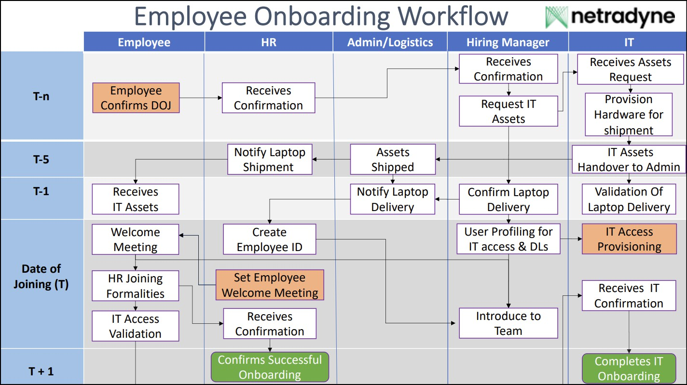

### Office 365 Account Creation – FTE & Interns

For full time employees & interns please follow below format while updating the O365 account.

* User principal name – [firstname.lastname@netradyne.com](mailto:firstname.lastname@netradyne.com)
* Mail nickname – <First letter of first name><First letter of last name><ND><IN/US based on user location><add 2 zeros followed by employee ID>

## Example1:

Employee Name - Chethan Gangaraju Employee ID - NDI083

Mail Nickname - [CGNDIN00083](mailto:CGNDIN00083@netradyne.com)

## Example2:

Employee Name - Mauricio Taxman Employee ID - NDUS00116

Mail Nickname - MTNDUS00116

* Display name – <Firstname><Space><Lastname>
* Password – Alphanumeric (character length 6-8)
* First name – Update first name of the employee
* Last name – Update last name of the employee
* Employee ID – Update once provided by HR team
* Designation – Update based on the input received in onboarding request (For Interns, please update “Intern” in designation field)
* Department – Update based on the input received in onboarding request
* Employee type – For Full time employees update FTE & for interns please update Intern
* Location – Update based on the input received in onboarding request
* Phone number – Update based on the input received in onboarding request (For US phone number should not be visible)
* Manager – Update based on the input received in onboarding request
* Employee Type – Update FTE for (full time employee) or Intern

### Roles and Responsibilities (Contractors)

This matrix helps clarify roles and responsibilities in the onboarding process, ensuring efficient coordination and accountability.

* **R =** Responsible: The person or role responsible for completing the task.
* **A =** Accountable: The person or role ultimately accountable for the task. This person has the final authority and responsibility.
* **C =** Consulted: The person or role consulted for input or feedback before the task is completed.
* **I =** Informed: The person or role who must be informed of the task's progress or completion.

|  |  |  |  |  |  |  |
| --- | --- | --- | --- | --- | --- | --- |
| **Onboarding Step** | **Hiring Manager** | **InfoSec Team** | **HR**  **Team** | **Reporting Manager** | **IT**  **Team** | **Contractor** |
| **1. Pre-Onboarding Preparation** |  |  |  |  |  |  |
| Contract agreement review and approval | C | R/A | R/A | C |  | I |
| Verify contractor/vendor credentials | R/A | C | R/A | C |  | I |
| Define scope of work and deliverables | R/A | C | R/A | C |  | C |
| Prepare necessary hardware and software | C |  |  | C | R/A | I |
| Set up access permissions | C |  |  | A | R | I |
| Prepare onboarding documentation | C | C | R/A | C |  | I |
| **2. Onboarding Day** |  |  |  |  |  |  |
| Conduct onboarding orientation | A | C |  | R |  | I |
| Distribute hardware (if applicable) | C |  |  | A | R | I |
| Provide system access and credentials | C |  |  | A | R | I |
| Configure software and tools | C |  |  | A | R | I |
| Security and compliance briefing | C | A |  | R |  | I |
| **3. Post-Onboarding Follow-Up** |  |  |  |  |  |  |

|  |  |  |  |  |  |  |
| --- | --- | --- | --- | --- | --- | --- |
| Monitor access and usage | C |  |  | R/A |  | I |
| Review deliverables and performance | R/A |  |  | R/A |  | C |
| Schedule periodic check-ins | R/A | C |  | R/A |  | I |
| Collect feedback from contractor/vendor | C |  |  | A |  | R |
| **5. Documentation and Record Keeping** |  |  |  |  |  |  |
| Update contract and vendor records | R/A | C |  | R/A |  | I |
| Maintain audit trail of access and usage | C |  |  | R/A | R/A | I |
| **6. Review and Updates** |  |  |  |  |  |  |
| Conduct post-engagement review | R/A | C |  | C |  | I |
| Update onboarding process based on lessons learned | R/A | C |  | C |  | I |

### Onboarding Process Workflow (Contractors)

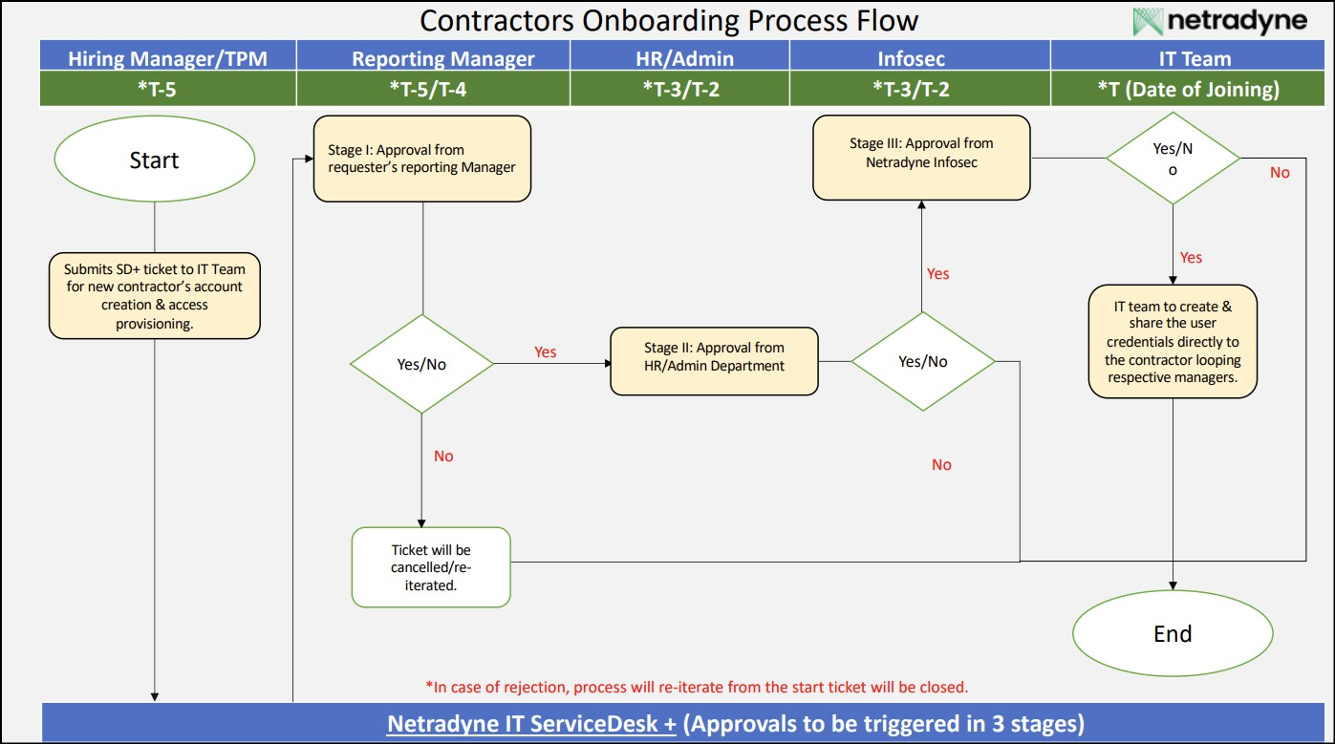

### Office 365 Account Creation - Contractors

For contractors, please follow below format while updating the O365 account.

* User principal name – [firstname.lastname.c@netradyne.com](mailto:firstname.lastname.c@netradyne.com)
* Mail nickname – firstname.lastname.c

**Note 1**: Standard Email ID nickname convention to be followed by the employees having employee ID

## Example1:

Employee Name - Chethan Gangaraju Employee ID - NDIC083

Mail Nickname - chethan.gangaraju.c

## Example2:

Employee Name - Mauricio Taxman Employee ID - NDIEXT00116

Mail Nickname – mauricio.taxman.c

**Note 2**: Standard Email ID nickname convention to be followed by the employees NOT having employee ID

## Example1:

Employee Name - Chethan Gangaraju Employee ID - Not Assigned

Mail Nickname – chethan.gangaraju.c

## Example2:

Employee Name - Mauricio Taxman Employee ID - Not Assigned

Mail Nickname – mauricio.taxman.c

* Display name – <Firstname><Space><Lastname>
* Password – Alphanumeric (character length 6-8)
* First name – Update first name of the employee
* Last name – Update last name of the employee
* Employee ID – Update once provided by HR team
* Designation – Update based on the input received in onboarding request (Please update “Contractor” in designation field)
* Department – Update based on the input received in onboarding request
* Employee type – Update Contractor
* Location – Update based on the input received in onboarding request
* Phone number – Update based on the input received in onboarding request (For US phone number should not be visible)
* Manager – Update based on the input received in onboarding request
* Employee Type – Contractor

### Exception for contractors in Europe

For contractors in Europe, please follow below format while updating the O365 account.

* + - * + User principal name – [firstname.lastname.c@netradyne.com](mailto:firstname.lastname.c@netradyne.com)

**Primary smtp** - [firstname.lastname@netradyne.com](mailto:firstname.lastname@netradyne.com)

**Secondary smtp** – [firstname.lastname.c@netradyne.com](mailto:firstname.lastname.c@netradyne.com)

* + - * + Mail nickname – firstname.lastname.c

**Note 1**: Standard Email ID nickname convention to be followed by the employees having employee ID

## Example1:

Employee Name - Chethan Gangaraju Employee ID - NDIC083

Email Nickname - chethan.gangaraju.c

## Example2:

Employee Name - Mauricio Taxman Employee ID - NDIEXT00116

Email Nickname – mauricio.taxman.c

**Note 2**: Standard Email ID nickname convention to be followed by the employees NOT having employee ID

## Example1:

Employee Name - Chethan Gangaraju

Employee ID - Not Assigned

Email ID Nickname – chethan.gangaraju.c

## Example2:

Employee Name - Mauricio Taxman Employee ID - Not Assigned

Email ID Nickname – mauricio.taxman.c

* + - * + Display name – <Firstname><Space><Lastname>
        + Password – Alphanumeric (character length 6-8)
        + First name – Update first name of the employee
        + Last name – Update last name of the employee
        + Employee ID – Update once provided by HR team
        + Designation – Update based on the input received in onboarding request
        + Department – Update based on the input received in onboarding request
        + Employee type – Update Contractor
        + Location – Update based on the input received in onboarding request
        + Phone number – Update based on the input received in onboarding request
        + Manager – Update based on the input received in onboarding request
        + Employee Type – Contractor

### Pre-Arrival Preparation

### Receive Notification of New Hire:

* HR to create ServiceDesk+ request for New Hire to the IT department at least one week before the start date.
* The form should include the employee’s name, role, department, start date, and any

specific IT requirements.

* ServiceDesk+ Template - [Onboarding Service Request](https://itservicedesk.netradyne.com/app/itdesk/ui/requests/add?reqTemplate=155142000004673341)

### Account Setup:

There are two steps for account creation:

1. **Primary Method**: Use the script to create the account from Greenhouse.
2. **Backup Option**: If the script fails, proceed with Step 2 to complete the account creation manually.

**Note** – There is an exception for Europe contractors, please refer 4.3.2.1

**Primary Method:**

Once user account is created in Greenhouse by HR team then use below document to create office 365 account.

Netradyne O365 Account Creation Greenhouse Procedure.docx

**Backup Option:**

* + Create an Active Directory (AD) account and assign an appropriate user role.

The IT team will create the O365 credentials for the user and assign the O365 license.

* + 1. Open the URL [https://admin.microsoft.com/](https://netradyne.atlassian.net/jira/your-work) and select **Active Users** on the left pane. Click **Add a user** to create account and assign the O365 license

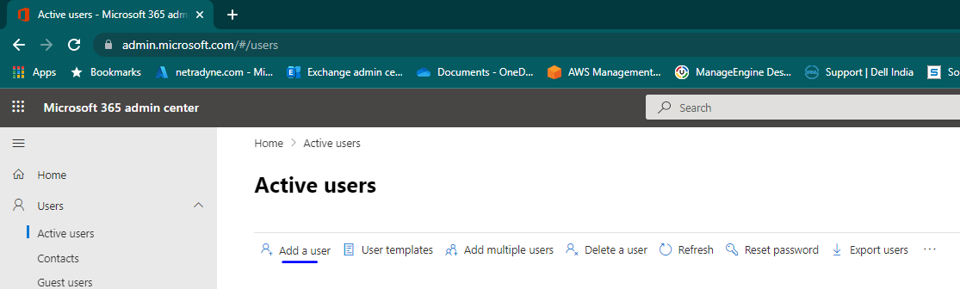

* + 1. Create email account and fill the required details based on section 4.2.2 & 4.3.2

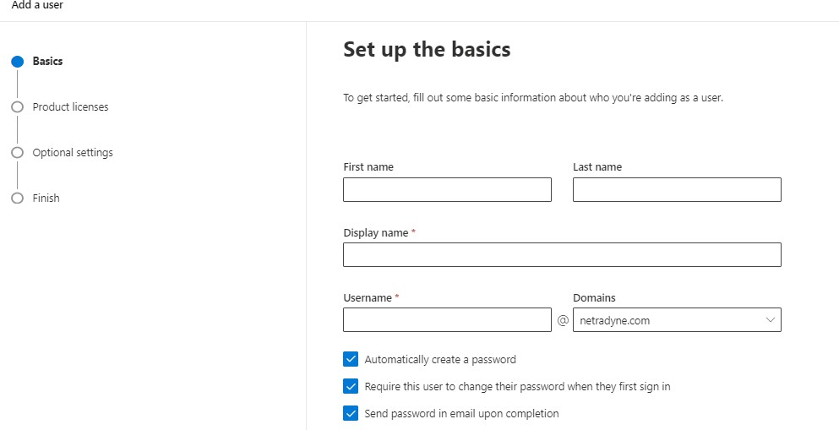

* + 1. IT team must share the user credentials to user’s personal email address and

copy user manager as well HR team

### User Profile Update:

1. Open the Azure AD portal [https://portal.azure.com/](https://www.knowbe4.com/) to update the user details. The account in Azure AD is automatically created once you create an account in O365.
2. Go to **All users** and search the new username in the search bar

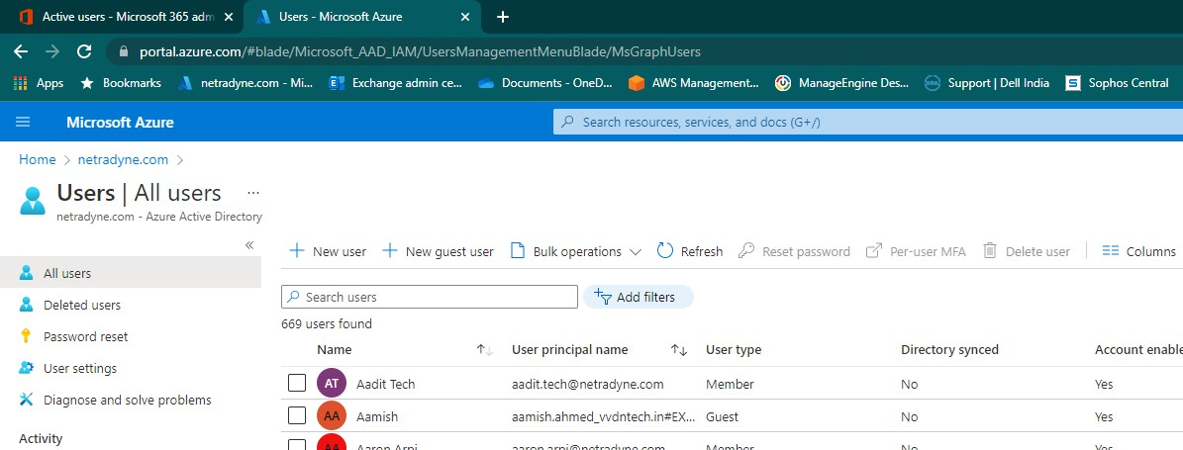

1. Click on Edit option to update the below user details:
   1. Employee ID
   2. Reporting Manager Name

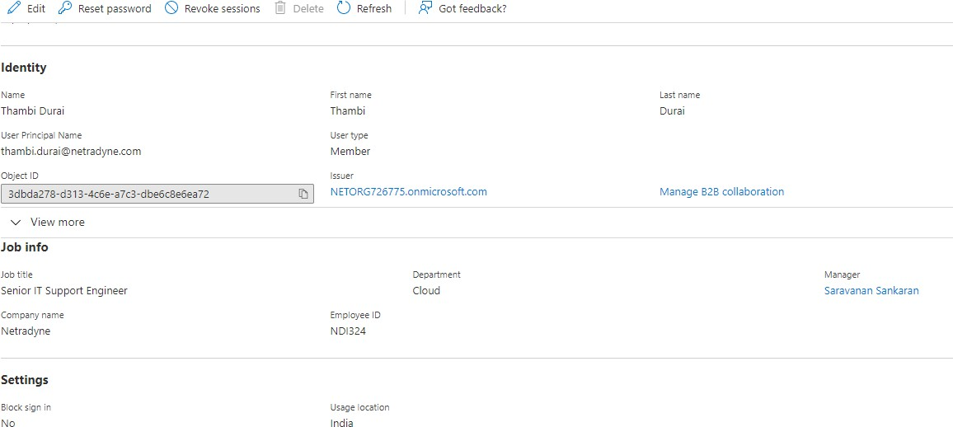

### Enable Multi-Factor Authentication (MFA):

1. Search the user in All Users & select the user record.
2. Enable the MFA for newly created user in Azure portal for enhanced security

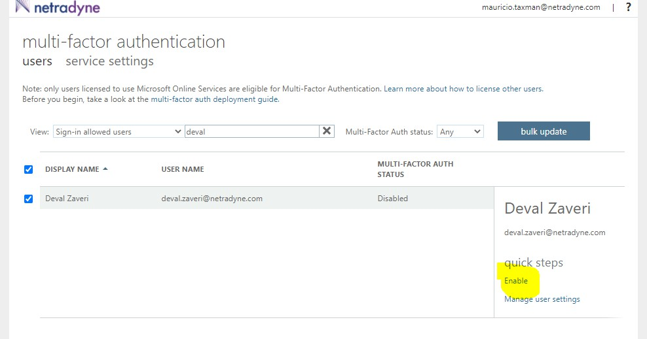

1. Click Per-User MFA as shown in the below screenshot

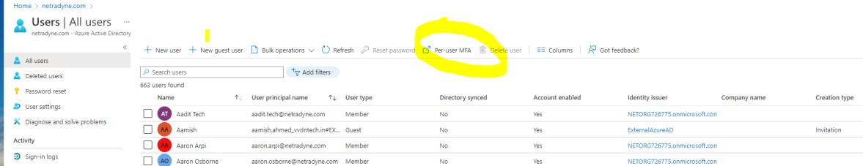

### IT Asset Allocation

The IT Team will allocate the laptop to the new employee based on the User Profiling Document.

* Hardware Profiling - Netradyne IT User Profiling.pdf
* **Laptop Preparation:** The default application should be installed on the laptop.
  + Desktop Central should be installed for all laptops
  + JAMF for Macs
  + CrowdStrike will be pushed automatically from backend

The encryption policy for Macs will also be pushed automatically from backend. For Windows and Ubuntu, encryption needs to be enabled during the laptop setup.

* **Hostname Allocation:** The host name for the laptop should be updated as per the below format:
  + **India**: nd-blr-firstname and initial letter of last name (Example: **nd-blr-subramanivelc**)
  + **US**: nd-us-firstname and initial letter of last name (Example: **nd-us-subramanivelc**)
* **Mandatory Applications/Software:** Default applications/software access will be provided based on the User Profiling Document. IT will send the email with default applications list to employees with CC the manager.
* Software/Application Profiling - Netradyne IT User Profiling.pdf
* **Laptop Handover to Employee:** Once laptop has been configured with all the configurations & applications, handover the same to the user and guide user to login into laptop with default password.

**Note**: Once user log-in with the default password, we will ask to set the new password. User must set the new password as per the password policy requirement. Provide the guidance to the user to setup Outlook, MS Teams, and other applications.

### Distribution Lists

1. Adding user into Default Distribution list groups in exchange admin centre. URL: [https://admin.exchange.microsoft.com/#/](https://admin.exchange.microsoft.com/%23/)
   * For Full time Employees:

India: [india-employees@netradyne.com](mailto:india-employees@netradyne.com)

US: [us-employees@netradyne.com](mailto:us-employees@netradyne.com)

* + For Intern, Contract Employees:

India: [india-contractemployees@netradyne.com](mailto:india-contractemployees@netradyne.com)

US: [us-contractemployees@netradyne.com](mailto:us-contractemployees@netradyne.com)

1. Go to recipients and select groups
2. Search the DL name and add the user

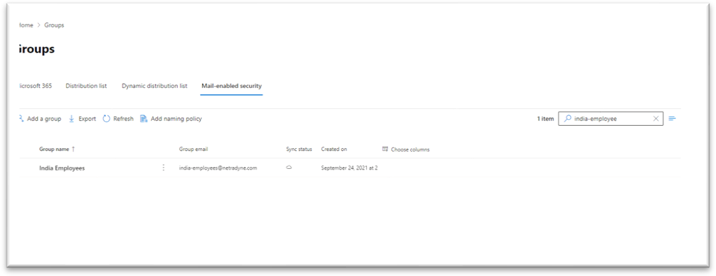

**Note:** For any other DL addition, User’s manager/HR shall raise a member addition request to the distribution list.

### Confirmation of Laptop Allocation

Employees need to fill the asset acknowledgement form on the day of onboarding.

* Asset Acknowledgement - [Netradyne Asset Acknowledgement](https://forms.office.com/Pages/ResponsePage.aspx?id=miFPuM0P-k2Edu3MlvMyTBgDbLh02jpGjnqJczL4a2VUNzhXUUFXVzFBVkVESTVIVEpGOEpXWVBDOC4u)

### Onboarding User Document Guide

Share the below link to the user for any onboarding assistance for IT. [Onboarding-Assistance-(Netradyne-Employees)](https://netorg726775.sharepoint.com/sites/IT/SitePages/Onboarding-Assistance-(Netradyne-Employees).aspx)

### Amazon Web Services (AWS)

1. Login to Microsoft Entra ID - <https://entra.microsoft.com/>
2. Go to Identity >> Groups >> All groups
3. Search for the group based on the department
4. Add member to the group

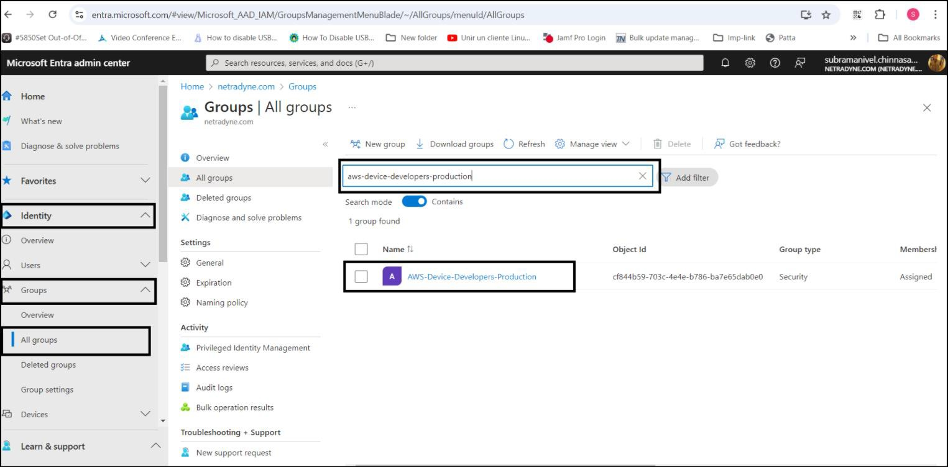

### Slack application access

1. Invites to user email address will be sent asking them to join Netradyne slack channels.

URL: <https://netradyne.slack.com/ssb/redirect>

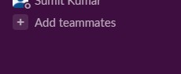

1. Then enter the user email address to send the invite.

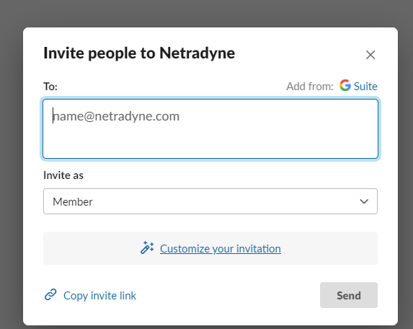

### Jira and Confluence Application Access

1. Jira is used for project management purpose and access will be given based on the user profiling document. Invitation will be sent to users email address to join into Jira tool - [https://netradyne.atlassian.net/jira/your-work](https://netradyne.slack.com/ssb/redirect)
2. Go to settings option in the right plane then select user account management

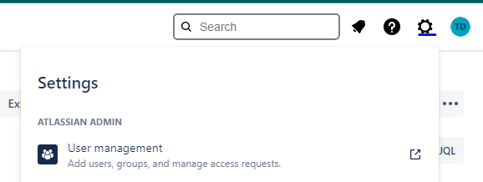

1. Then select Invite user tab and enter the user official email address to send the invite

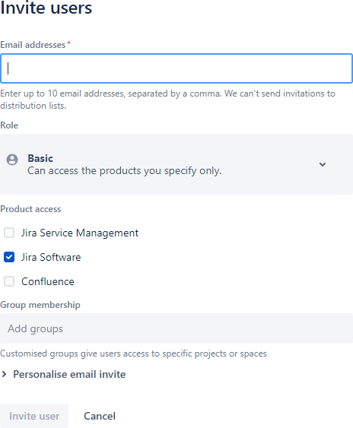

### GitHub application

1. Employee must access the URL: [https://github.com/](mailto:firstname.lastname.c@netradyne.com) and self-sign themselves for new GitHub account. They need to use their official Netradyne email ID

Note: Set username of GitHub account in “FirstName with LastName first alphabet-nd”

format

Ex: Chethang-nd is the GitHub username for Chethan Gangaraju user.

1. Once the GitHub account is created, Employee need to raise the SD+ with the GitHub username and the list of repositories that Employee needs access.

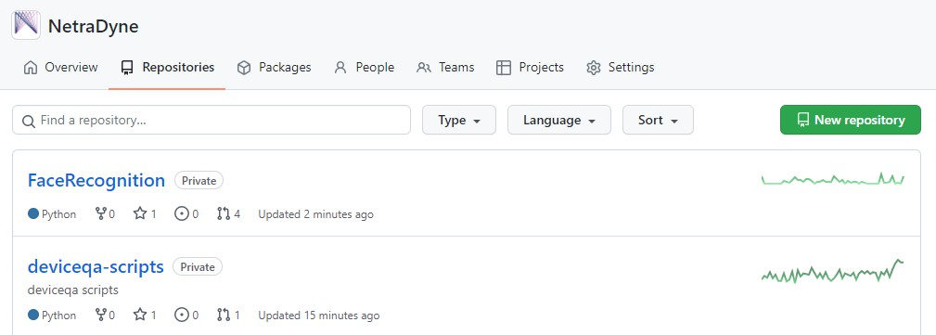

### IDMS application

1. IDMS is an internal developed application which is used for internal users as well as customers to manage the products.

IDMS have staging and production environments.

**IDMS-staging**: [https://idms-staging.netradyne.com/console/#/](https://portal.azure.com/%23/)

1. Based on the user department we will create the user roles and customer is set to **The Best Fleet company** for all internal users in staging

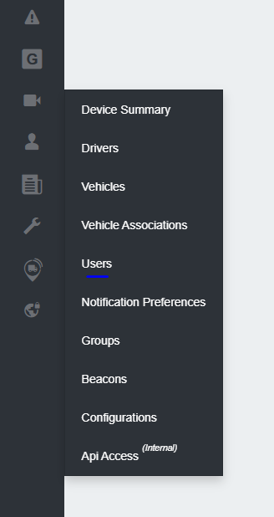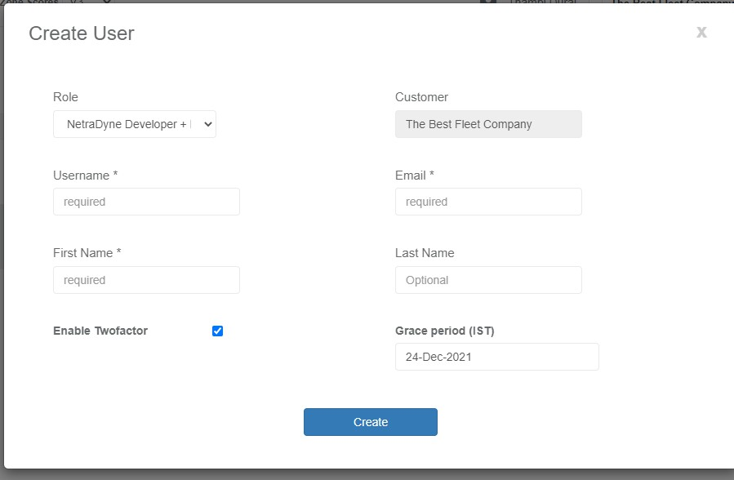

**IDMS-Prod**: [https://idms.netradyne.com/console/#/](https://idms.netradyne.com/console/%23/)

1. Based on the user department we will create the user roles and customer is set to

**Netradyne** for all internal users in production.

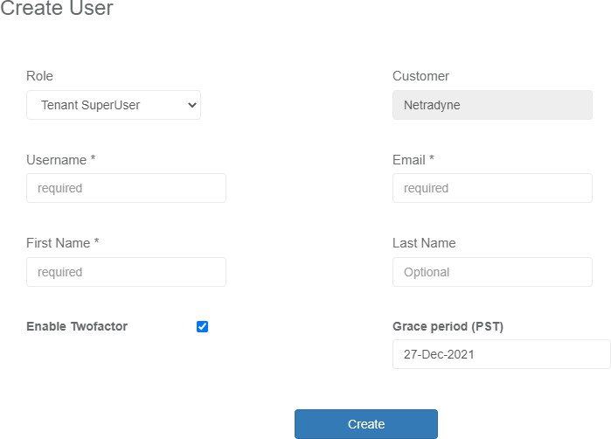

### Cisco VPN

1. We will provide Cisco VPN application access based on user profiling document.
2. Download the client and configure the VPN to access the Netradyne network from public internet.
3. To provide the access, login into azure AD portal [https://portal.azure.com/](https://zoom.us/account/user) and select enterprise application then search cisco AnyConnect.

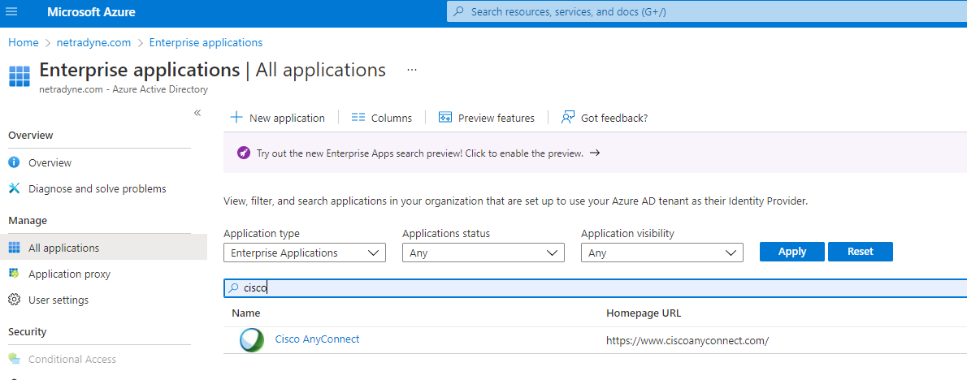

1. Then add the user into Assign users and groups

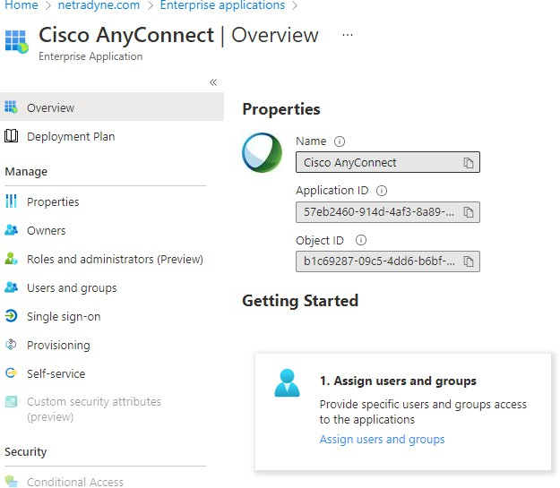

### Knowbe4 application

1. Knowbe4 is a platform to use for security awareness training.
2. it is a default access for all Netradyne employees.
3. The application is already integrated with Azure AD, so users can use with O365 credentials to login - [https://www.knowbe4.com/](https://admin.vonage.com/management/m/dashboard)

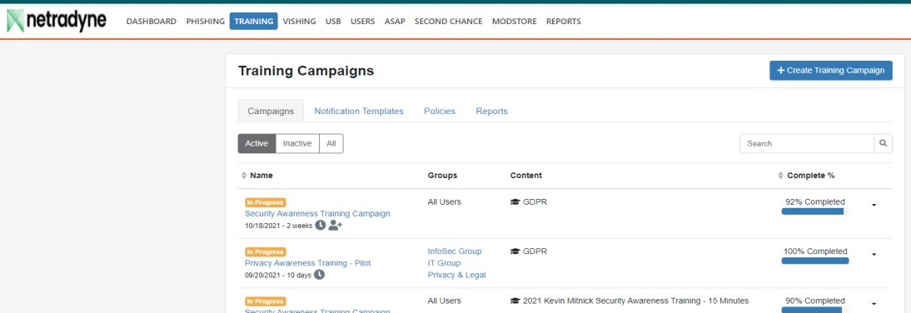

### PagerDuty

Access to pager duty application based on the User Profiling Document.

### Pingdom

we will provide the access to Pingdom application based on the User Profiling Document.

### Datadog

1. Access to Datadog application based on the User Profiling Document. URL: <https://app.datadoghq.com/organization-settings/users>
2. Default Role: Datadog Read only Role
3. Login to the above user and sent the invitation to the users.

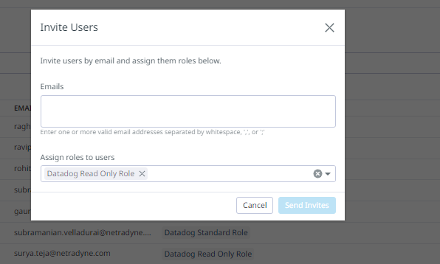

### Sentry

1. Access to Sentry application based on the User Profiling Document. URL: <https://netradyne.sentry.io/settings/members/>
2. Login to the above user and sent the invitation to the users.
3. Based on the user department we will add to the specific teams.

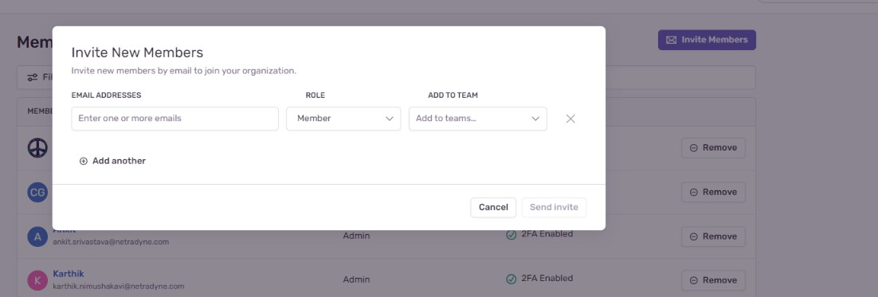

### Zoom Access

1. The zoom application is integrated with Azure AD
2. users can use with O365 credentials to login.
3. Add users to [**AAD-Zoom-SSO-Users**](https://entra.microsoft.com/)Group in Azure AD.

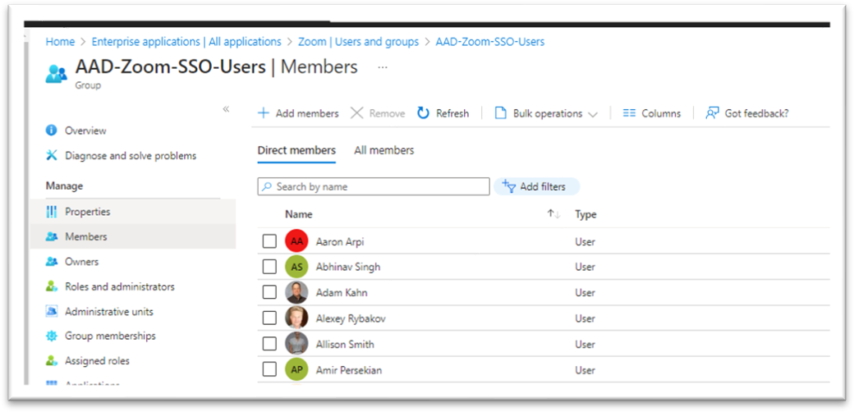

### ServiceDesk+

1. The SD+ application is integrated with Azure AD
2. Users can use with O365 credentials to login
3. Users will be added to the application by automatically
4. User will get the access on the day of onboarding

### New User Onboarding Notifications

This is the sample notification that will be shared with the new user, with hrops- [india@netradyne.com,](mailto:india@netradyne.com) [it@netradyne.com,](mailto:it@netradyne.com) HR Manager, and the User’s Manager in CC.



Welcome to Netradyne _ Accounts

### Key Contacts

|  |  |  |  |
| --- | --- | --- | --- |
| **Name** | **Contact** | **Email ID** | **Role** |
| Priyesh Parashar | 9845227014 | [priyesh.parashar@netradyne.com](mailto:priyesh.parashar@netradyne.com) | Sr. ITSM Analyst |
| Chethan Gangaraju | 9916322439 | [chethan.gangaraju@netradyne.com](mailto:chethan.gangaraju@netradyne.com) | Staff Manager - IT Infrastructure |
| Saravanan Sankaran | 9444161422 | [saravanan.sankaran@netradyne.com](mailto:saravanan.sankaran@netradyne.com) | Sr. Director - Info Security & IT |

# Conduct

Compliance Checks to this process to be performed through various methods, including but not limited to reports, internal/external audits, Awareness training/assessments and feedback to the process owner. Non-compliance will be escalated to the Netradyne leadership team.

# Exception

Exception to this procedure must be approved through the Netradyne Exception Process.

# Terms/Acronyms

|  |  |
| --- | --- |
| **Term/Acronym** | **Definition** |
| AD | Active directory |
| IT | Information Technology |
| HR | Human Resource |
| MFA | Multi Factor Authentication |
| FTE | Full Time Employee |
|  |  |
|  |  |

# References

### Templates

*Netradyne IT User Profiling* [Netradyne Asset Acknowledgement](https://forms.office.com/Pages/ResponsePage.aspx?id=miFPuM0P-k2Edu3MlvMyTBgDbLh02jpGjnqJczL4a2VUNzhXUUFXVzFBVkVESTVIVEpGOEpXWVBDOC4u) [Onboarding Assistance](https://netorg726775.sharepoint.com/sites/IT/SitePages/Onboarding-Assistance-(Netradyne-Employees).aspx)

Contractor_Onboarding_workflow.pdf Employee_Onboarding_workflow.pdf

### Policies

*Netradyne Information Security Policy & Procedure.pdf Netradyne Information Security Exception Process.pdf IT Guidelines for Software Purchases.pdf*

*Netradyne Acceptable Usage Policy.pdf Netradyne Change Management.pdf Netradyne Incident Management.pdf*

*Netradyne Information Technology Policy and Procedure.pdf Netradyne IT Asset Policy.pdf*

*Netradyne IT Asset Policy.pdf Netradyne Problem Management.pdf NetradyneOpen-SourceSecurityPolicy.pdf*

### Process/Procedures

*NETRADYNE DISASTER RECOVERY PROCESS.pdf NETRADYNE BUSINESS CONTINUITY PLAN.pdf*

*Netradyne Vulnerability & Patch Management Process.pdf NetradyneSecurityIncidentResponsePlan.pdf*

*Netradyne Employee ID Update Greenhouse Procedure.docx Netradyne O365 Account Creation Greenhouse Procedure.docx Netradyne-Access_Control_matrix.xlsx*

*Netradyne Employee Mail Nickname Update Greenhouse Procedure.pdf*

# Appendix A: Document RACI Matrix

|  |  |  |  |  |  |  |  |  |
| --- | --- | --- | --- | --- | --- | --- | --- | --- |
| **Role/Activity** | | **Document Owner/Functional Area Lead** | | **Document Contributor** | **ND**  **Leadership** | **Functional Area Team** | **InfoSec** | **All ND Member(s)** |
| **Ensure document is kept current** | | A | | R | I, C | R, C | C | I |
| **Ensure stakeholders are kept**  **informed** | | A | | R | - | R | C | - |
| **Ensure document contains all**  **relevant information** | | A | | R | I, C | R, C | C | I |
| **Ensure document adheres to document governance**  **policy** | | A, R | | R | I | R, C | R, C | I |
| **Provide SME advice** | | I, R | | A, R | I | R, C | I, C | I |
| **Gathering and adding document contents** | | I | | A, R | I, C | R, C | C | I |
| **Document Approval** | | A | | R | I, R | I | I, R | I |
| *Key* | | | | | | | | |
| *R* | Responsible | |  | | | | | |
| *A* | Accountable | |
| *C* | Consulted | |
| *I* | Informed | |